 | European Commission  DIRECTORATE GENERAL  INFORMATICS | 

e-TrustEx - Use Case Realization
Apply SLA and Retention Policy

European Commission, B-1049 Brussels – Belgium, Telephone: (32-2) 299 11 11
Original Template Author: DIGIT.01.MIA – Version 2012-01

Document Control Information
Settings | Value
Directorate: | INFORMATICS
Project Name: | e-TrustEx
Document Author: | Anamaria BATRINU
System Owner: | Tanya Chetcutti
Project Manager: | Tanya Chetcutti
Revision Status: | Draft
Sensitivity: | Limited DG
Issue Date: | <Issue Date>
*Please use only the here above button to update Document Properties. Updating in the table directly will break the mechanism. If the settings in this table are not working anymore, then you can copy and paste the full table from the original template.

Document Approver(s):
(All Approvers are required. Records of each approver must be maintained.)
Approver Name | Role
[Name] | [Role]

Document Reviewers: (Records of each required reviewer must be maintained.)
Reviewer Name | Role
[Name] | [Role]

NOTE: All Reviewers in the list are considered required unless explicitly listed as Optional.

Summary of Changes:
The Document Author is authorized to make the following types of changes to the document without requiring that the document be re-approved:
- Editorial, formatting, and spelling
- Clarification

To request a change to this document, contact the Document Author or Owner.
Changes to this document are summarized in the following table in reverse chronological order (latest version first).

Revision | Date | Created by | Short Description of Changes
[1] | [09/10/2014] | [Anamaria BATRINU] | [First draft]
[2] | [02/04/2015] | [Anamaria BATRINU] | [Added deletion of associations between messages and routing configurations for retention policy application]
[3] | [18/05/2016] | [Anamaria BATRINU] | [JIRA ETRUSTEX-1360]

Configuration Management: Document Location
The latest version of this controlled document is stored in [this location].

TABLE OF CONTENTS
Introduction 4
1.1 Description 4
1.2 Definitions, Acronyms, and Abbreviations 4
1.3 References 4
1.4 Overview 4
2. Design 4
2.1 SLA and Retention Policy Configuration 4
2.1.1 SLA Configuration 5
2.1.2 Retention Policy Configuration 5
2.2 Class Model 6
2.2.1 Class Diagram 6
2.2.1.1 Retention Policy 6
2.2.1.2 SLA Policy 7
2.2.2 Class Definition 9
2.3 Implementation 10
2.3.1 Retention policy 10
2.3.2 SLA Policy 12
2.3.2.1 SLA_VOLUME 12
2.3.2.2 SLA_SIZE 12
2.3.2.3 SLA_COUNT 12
2.4 Sequence Diagram 13
2.4.1 Retention Policy 13
2.4.2 Validation of SLA_COUNT 14
2.4.3 Validation of SLA_VOLUME and SLA_SIZE 15
2.5 Exceptions 16
2.6 Logging Information 16

Introduction

Description
This Use Case Realization describes the implementation of the Use Case Verify and Apply Retention Policy and of the sections .

Definitions, Acronyms, and Abbreviations
Acronym, Abbreviation or Definition | Explanation
UC | Use Case
UCR | Use Case Realization
SLA | Service Level Agreement

References
Reference Id | Reference Name | Owner/Author
R1 | e-TrustEx Software Architecture Document | Sandro D'Orazio
R2 | Verify and Apply Retention Policy | Anamaria BATRINU
R3 | Validate and Store Document Wrapper | Alice Vasilescu
R4 | Validate Document Bundle | Alice Vasilescu

Overview
This document presents the Use Case Realization as a series of views: Class Diagram view, and Sequence Diagram view, using the Unified Modelling Language (UML).

Design

SLA and Retention Policy Configuration

The SLA and Retention Policy configurations are done at the level of the database, in the database table named ETR_TB_SLA_POLICY.

SLA Configuration
The SLA configuration is done at the business domain level and it is used to configure
- The maximum size of a binary file attached to a wrapper
- The maximum number of wrappers per bundle
- The maximum volume of data that can be exchanged in a defined period

Note. There is no default SLA Policy configuration to use in case a business domain has no SLA policies configured. When creating a business domain, one shall always configure all SLA policies applicable for it.

SLA - maximum size of a binary file attached to a wrapper

SLA - maximum volume of data that can be exchanged in a defined period

Business Domain

SLA - maximum number of wrappers per bundle

Retention Policy Configuration
The Retention Policy configuration is done at the business domain level and per document type (transaction) and it is used to configure for how long a document shall be kept in the system.
After the configured period expires, the document shall be removed from the system's database.

Currently, retention policy is only configured for SubmitBundle and StoreWrapper transactions.

Note. There is no default Retention Policy configuration to use in case a business domain has not Retention policies configured. When creating a business domain, one shall always configure all retention policies applicable for it.

Retention policies for bundles of transactions

Business Domain

Transaction

Retention policies for specific transactions

Class Model

Class Diagram

Retention Policy
Figure 1. Core Data Model used with Retention Policy
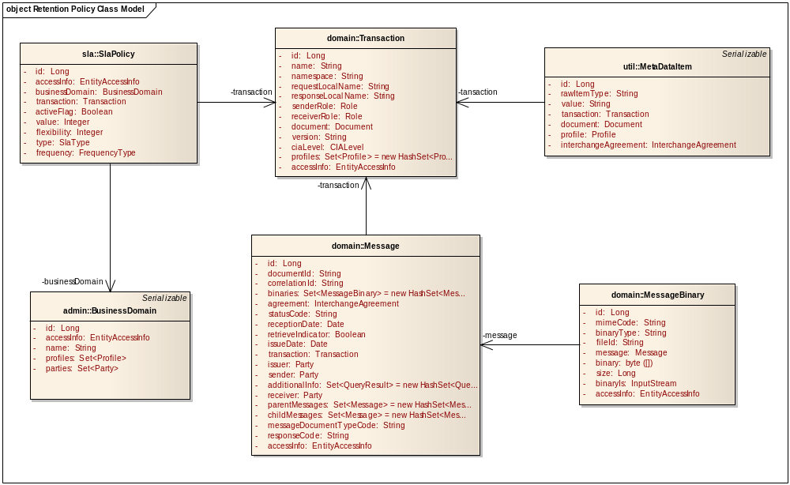

Figure 2.Class Diagram for Retention Policy
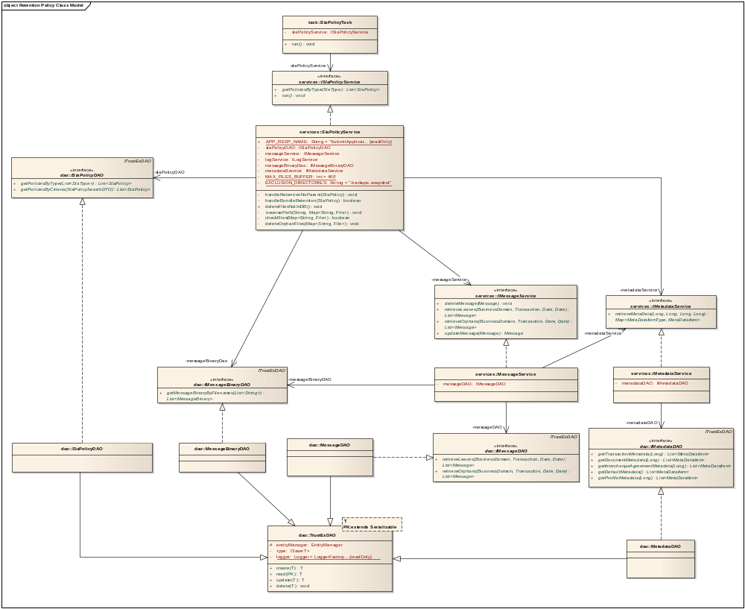

SLA Policy

Figure 3.Core Data Model used with SLA Policy
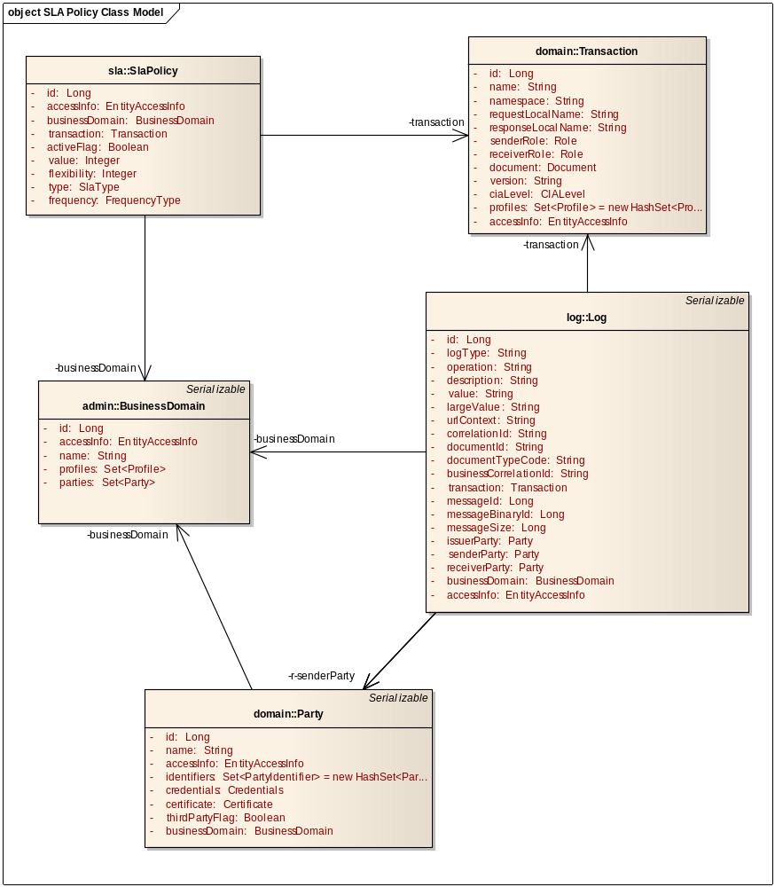
Figure 4. Class Diagram for SLA Policy
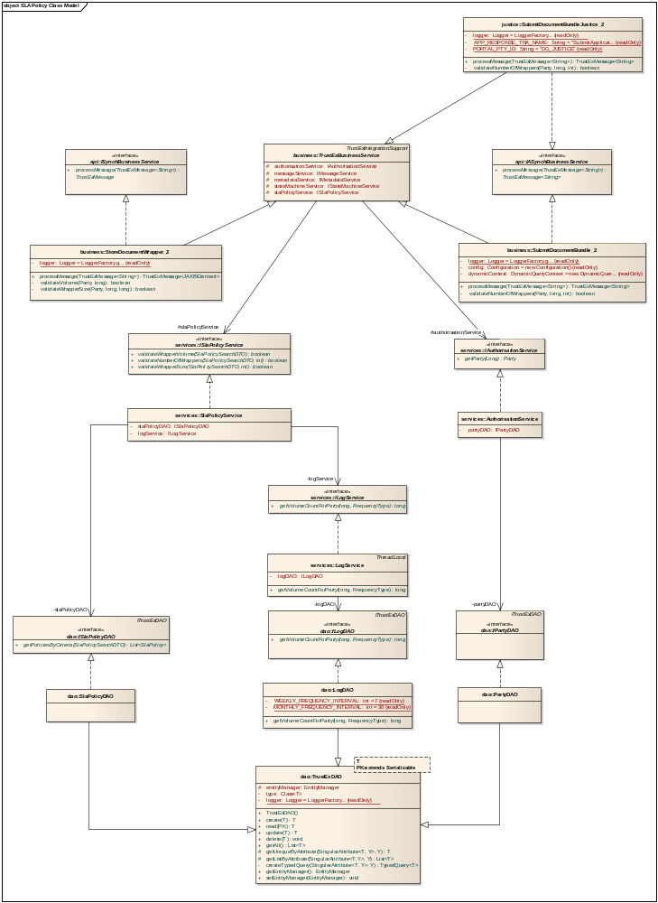

Class Definition

The SlaPolicy class is used to hold the Service Level Agreement and Retention Policy configurations. It corresponds to the database table ETR_TB_SLA_POLICY. The table below contains the SlaPolicy fields, their corresponding table fields, a detail description for each of them and specifies if a field is used for SLA or Retention Policy configuration, or both.

Property | Table column name | Usage |  | Description
Property | Table column name | SLA | RP | Description
id | SLA_ID | X | X | The database id of the SLA or Retention Policy configuration
businessDomain | SLA_BD_ID | X | X | The business domain for which the retention policy or SLA shall be used
transaction | SLA_TRA_ID | - | X | The transaction for which the retention policy shall be used
activeFlag | SLA_ACTIVE_FL | X | X | Indicates if the configuration is active or not. Only active configurations shall be used when applying the policies.
value | SLA_VALUE | X | X | The value that shall be used when applying the policies:  - The number of days, when SLA_TYPE = RETENTION_BUNDLE or RETENTION_WRAPPER  - The size  - in MB for SLA_TYPE = SLA_SIZE  - in GB for SLA_TYPE = SLA_VOLUME  - number of wrappers for SLA_TYPE = SLA_COUNT
flexibility | SLA_FLEXIBILITY | X | - | The marge to use for SLA volume transferred
type | SLA_TYPE | X | X | SLA or Retention Policy types. Possible values:  - RETENTION_BUNDLE – used to configure the minimum number of days that a bundle shall be retained in the system  - RETENTION_WRAPPER – used to configure the minimum number of days that a wrapper shall be retained in the system  - SLA_VOLUME – used to configure the maximum volume of data (in Gb) that can be exchanged in a given period  - SLA_COUNT – used to configure the maximum number of wrappers per bundle pertaining to a business domain  - SLA_SIZE – used to configure the maximum size of a binary file (in Mb) that is attached to a wrapper
frequency | SLA_FREQUENCY | X | - | The period for which the SLA maximum exchanged volume is allowed.

Implementation

Retention policy
eTrustEx runs a scheduled task SlaPolicyTask, for which a scheduled interval can be configured. From within the task, it is called the run() method of SlaPolicyService where all retention policy rules are checked and data not in the retention period is deleted from the system (both from the database and the file store) .

The retention period is considered to start N days before the current date, where N is the number of days that have been configured for the retention policy.
The documents to be deleted are considered to be the ones that have been created or modified less than 20 years from the current date, but before the start of the retention period of the corresponding retention policy. This period will be referred to as non-retention period in the rest of this document.

The System applies the retention policy in 3 steps:
- In the first step it is checked the retention policy for bundles. The system retrieves all Bundle retention policies by calling the method getPoliciesByType of SlaPolicyDao, and for each active policy we check and apply the policy using the method handleBundleRetention of SlaPolicyService:
  - System retrieves all bundle messages corresponding to the policy's business domain and transaction that have no bundle child messages and are in the non-retention period by calling the method retrieveLeaves of MessageService, and for each such message
    - Removes the connections to the parent messages
    - Removes the connections to child messages (like application response, wrappers) and deletes the application response child messages from the database (and their corresponding binaries from the file store) as well as their associations with the routing configurations used for knowing the dispatched status
    - Deletes the message binaries from the file store
    - Deletes the associations between the message and the routing configurations used for knowing the message dispatched status
    - Deletes the message from the database
    - Notifies the concerned parties of the message deletion
  - Repeat step a until no more messages can be retrieved
- In the second step it is checked the retention policy for wrappers. The system retrieves all Wrapper retention policies by calling the method getPoliciesByType of SlaPolicyDao, and for each active policy we check and apply the policy using the method handleRetentionNoParent of SlaPolicyService:
  - System retrieves all wrapper messages corresponding to the policy's business domain and transaction that have no parent and are in the non-retention period by calling the method retrieveOrphans of MessageService, and for each such message
    - Deletes the message binaries from the file store
    - Deletes the message from the database
    - Notifies the concerned parties of the message deletion
- In the third step, if system is configured to use file store for keeping documents
  - System retrieves all configured file stores
  - For each file store, excepting defined directories, system deleted the documents that are not link to from the database

SLA Policy
The SLA Policies are applied in the case of two business services: StoreDocumentWrapper_2 and SubmitDocumentBundle_2. In the StoreDocumentWrapper_2 it is checked that the maximum size of a binary attached to a wrapper (SLA_SIZE) and the maximum volume of data that can be exchanged in a defined period (SLA_VOLUME) are not exceeded, whilst in the SubmitDocumentBundle_2 it is checked if the maximum number of wrappers of the bundle (SLA_COUNT) is not exceeded.

SLA_VOLUME
The check of SLA_VOLUME policy is done in the processMessage method of StoreDocumentWrapper_2 business service by calling validateVolume method having as parameters:
- the sender party retrieved using getParty method of AuthorisationService, and
- the transaction id

A MessageProcessingException is generated in case the configured maximum volume is exceeded, having the information specified in Validate and Store Document Wrapper Use Case Specification and the processing stops. At the end, BusinessProcessActivator catches the exception and logs the error in the database.
Note: Current implementation catches this MessageProcessingException under Exception and logs an unknown error instead of specific SLA policy rule violation (logDTO.setDescription(logDTO.getDescription() + " Unknown Error Occured while while calling the synch business service " + e.getMessage());).

SLA_SIZE
The check of SLA_SIZE policy is done in the processMessage method of StoreDocumentWrapper_2 business service, where for each message binary specified in the wrapper, the validateWrapperMessage is called having as parameters:
- the sender party retrieved using getParty method of AuthorisationService,
- the transaction id, and
- the binary message size, obtained after retrieving the binary message by calling the method retrieveMessageBinary of MessageService

A MessageProcessingException is generated in case the configured maximum size of a binary is exceeded, having the information specified in Validate and Store Document Wrapper Use Case Specification and the processing stops. At the end, BusinessProcessActivator catches the exception and logs the error in the database.
Note: See note from section 2.3.2.1 SLA_VOLUME.

SLA_COUNT
The check of SLA_COUNT policy is done in the processMessage method of SubmitDocumentBundle_2 business service by calling validateNumberOfWrappers method having as parameters:
- the sender party retrieved using getParty method of AuthorisationService,
- the transaction id, and
- the size of the wrapper list
Based on these parameters, the method constructs the SlaPolicySearchDTO and passes it to the method validateNumberOfWrappers of slaPolicyService together with the size of the wrapper list.

Sequence Diagram

Retention Policy

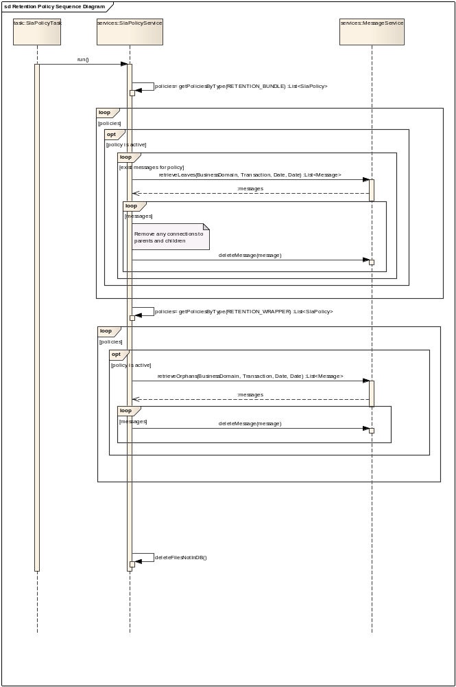

Validation of SLA_COUNT

The sequence diagram for the SLA_COUNT policy validation is similar for both SubmitDocumentBundle_2 and SubmitDocumentBundleJustice_2 business services. In the figure below, the diagram presented is the one corresponding to the SubmitDocumentBundle_2 business service.
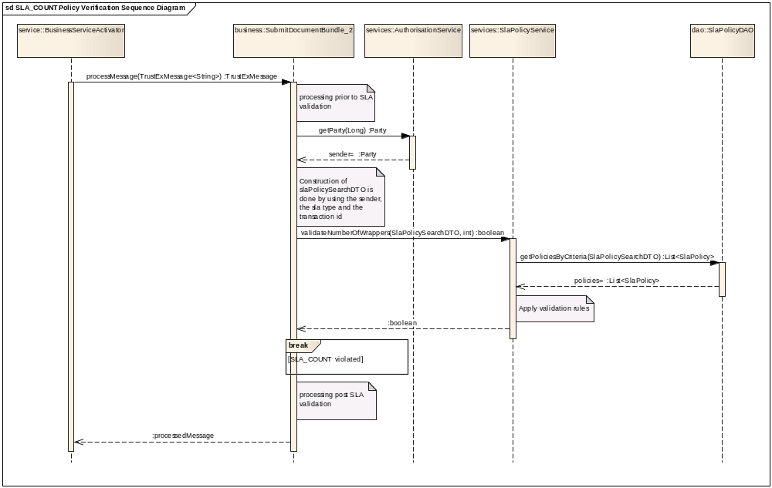

Validation of SLA_VOLUME and SLA_SIZE
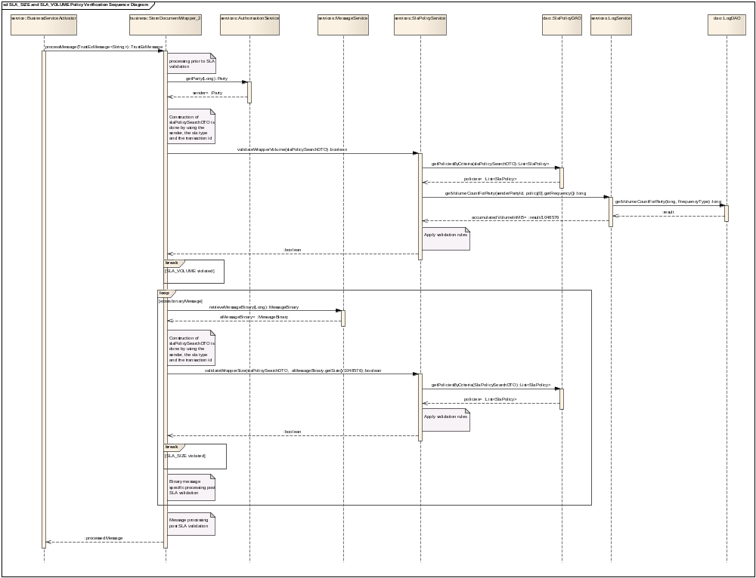

Exceptions

Logging Information
Logging information is stored in ETR_TB_LOG table. The following information mapping is used:

Table field | Information | On success | On error
LOG_ID | Log identification information – auto generated | x | x
LOG_TYPE | SUCCESS on successful operation, ERROR or EXCEPTION on business errors or exceptions | x | x
LOG_OPERATION | Message dispatch operation: MSG_DISPATCH | x | x
LOG_DESCRIPTION | A user friendly message | x | x
LOG_LARGE_VALUE | The stacktrace, where it is the case | - | x
LOG_CORRELATION_ID | The log correlation identifier | x | x
LOG_DOCUMENT_ID | The message document identifier | x | x
LOG_BUS_CORRELATION_ID | The message correlation identifier | x | x
CRE_DT | Creation date: the system date | x | x
MOD_DT | Modification date: the same with creation date. It never changes. | x | x
CRE_ID | Creation user, which is the system user TRUSTEX. | x | x

